SECRETS
A Secret in Kubernetes is an object that is used to store sensitive information (such as passwords, tokens, and keys) in a secure and encoded format so it can be safely used by Pods without exposing the data directly in application code or configuration files.

The main purposes of Secrets include:
Data Protection: Though Secrets are not encrypted by default when stored in etcd (the storage backend for Kubernetes), they can be with the right configuration, which means sensitive data is better protected than if it were stored in a plain ConfigMap.

Decoupling sensitive content:
Similar ConfigMap, Secrets allow you to decouple sensitive content from pods, promoting a clean separation of concerns.
Scoped Access: You can fine-tune which pods can access a specific Secret using Kubernetes RBAC.

Step 1 — Create MySQL ConfigMap
This stores non-sensitive data.

Vi mysql-config.yaml
apiVersion: v1
kind: ConfigMap
metadata:
name: mysql-config
data:
MYSQL_HOST: mysql-service
MYSQL_USER: root
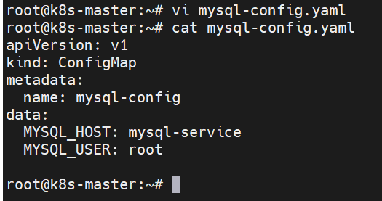

kubectl apply -f mysql-config.yaml

kubectl get configmap mysql-config -o yaml

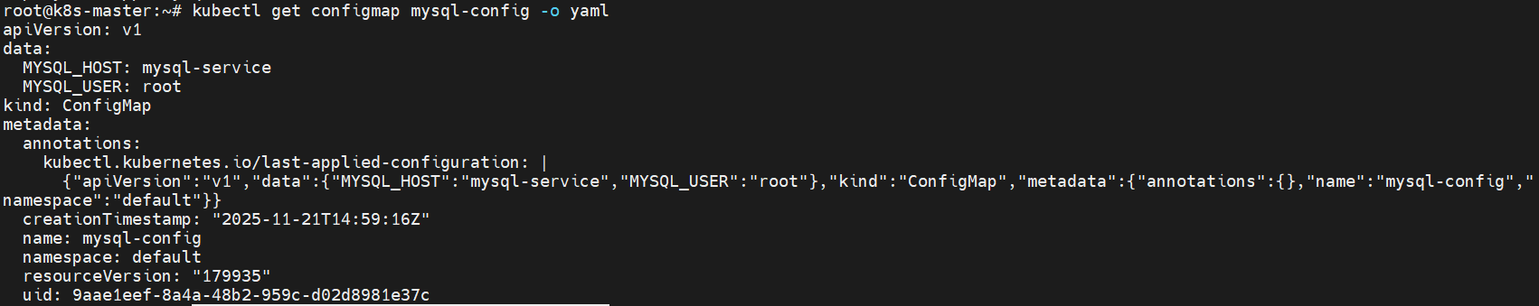

Step 2 — Create MySQL Secret
This stores sensitive data (password).

Option 1 — Generic Secret
(base64 of rootpass → cm9vdHBhc3M=)

Vi mysql-secret.yaml
apiVersion: v1
kind: Secret
metadata:
name: mysql-secret
type: Opaque
data:
MYSQL_PASSWORD: cm9vdHBhc3M= # base64 of 'rootpass'

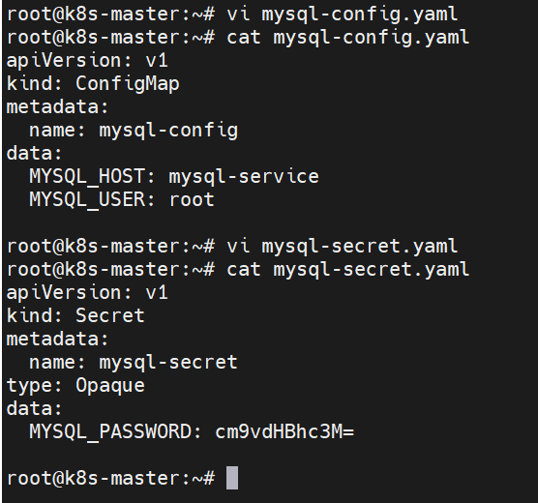
kubectl apply -f mysql-secret.yaml
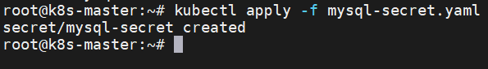

kubectl get secret mysql-secret -o yaml
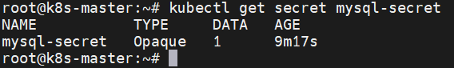

Step 3 — Create MySQL Deployment

mysql-deployment.yaml
apiVersion: apps/v1
kind: Deployment
metadata:
name: mysql
spec:
replicas: 1
selector:
matchLabels:
app: mysql
template:
metadata:
labels:
app: mysql
spec:
containers:
- name: mysql
image: mysql:5.7
ports:
- containerPort: 3306
env:
- name: MYSQL_ROOT_PASSWORD
valueFrom:
secretKeyRef:
name: mysql-secret
key: MYSQL_PASSWORD
- name: MYSQL_USER
valueFrom:
configMapKeyRef:
name: mysql-config
key: MYSQL_USER
- name: MYSQL_HOST
valueFrom:
configMapKeyRef:
name: mysql-config
key: MYSQL_HOST
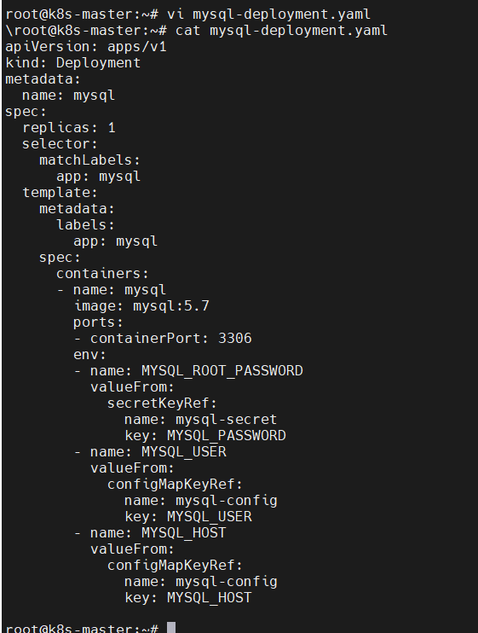
kubectl apply -f mysql-deployment.yaml
kubectl get pods -l app=mysql
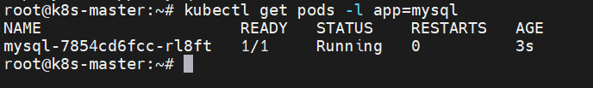

Step 4 — Create MySQL ClusterIP Service

Vi mysql-service.yaml
apiVersion: v1
kind: Service
metadata:
name: mysql-service
spec:
selector:
app: mysql
ports:
- protocol: TCP
port: 3306
targetPort: 3306
type: ClusterIP

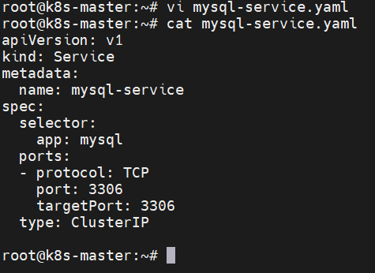
kubectl apply -f mysql-service.yaml
kubectl get svc mysql-service
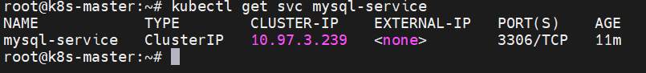

Step 5 — Create MySQL Client Pod
You will use this to test connection.

Vi mysql-client-pod.yaml
apiVersion: v1
kind: Pod
metadata:
name: mysql-client
spec:
containers:
- name: mysql-client
image: mysql:5.7
command: ["sh", "-c", "sleep 3600"]
env:
- name: MYSQL_HOST
valueFrom:
configMapKeyRef:
name: mysql-config
key: MYSQL_HOST
- name: MYSQL_USER
valueFrom:
configMapKeyRef:
name: mysql-config
key: MYSQL_USER
- name: MYSQL_PASSWORD
valueFrom:
secretKeyRef:
name: mysql-secret
key: MYSQL_PASSWORD
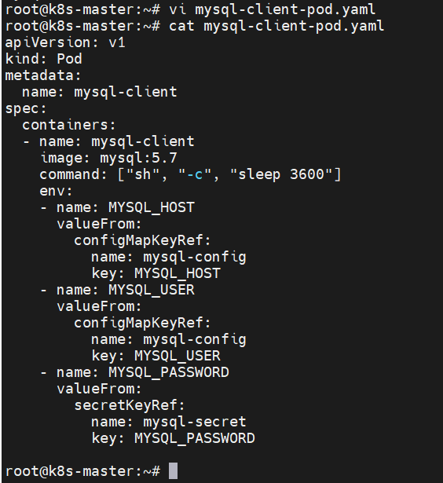

kubectl apply -f mysql-client-pod.yaml
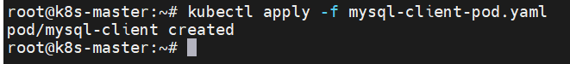

kubectl get pod mysql-client
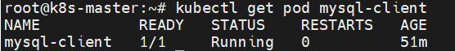

Create MySQL Deployment
Create file:

mysql-deployment.yaml
apiVersion: apps/v1
kind: Deployment
metadata:
name: mysql
spec:
replicas: 1
selector:
matchLabels:
app: mysql
template:
metadata:
labels:
app: mysql
spec:
containers:
- name: mysql
image: mysql:5.7
ports:
- containerPort: 3306
env:
- name: MYSQL_ROOT_PASSWORD
valueFrom:
secretKeyRef:
name: mysql-secret
key: MYSQL_PASSWORD
Apply it:
kubectl apply -f mysql-deployment.yaml
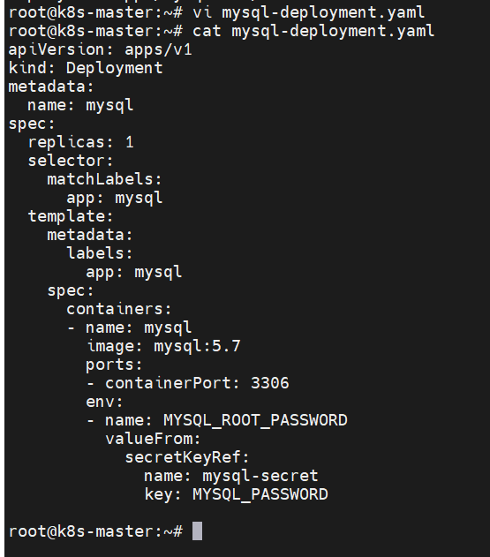

Step 6 — Test MySQL Connection
Login to client pod:
kubectl exec -it mysql-client – sh
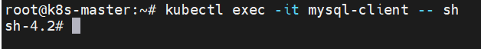
Check environment variables:
echo "Host: $MYSQL_HOST"
echo "User: $MYSQL_USER"
echo "Password: $MYSQL_PASSWORD"
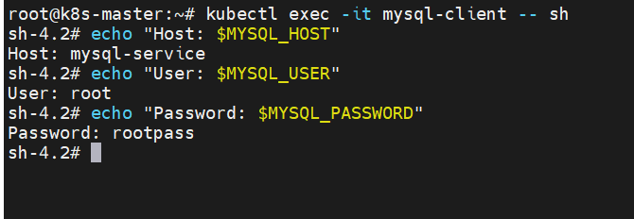

kubectl exec -it mysql-client -- sh

mysql -h mysql-service -u root -p
mysql -h $MYSQL_HOST -u$MYSQL_USER -p$MYSQL_PASSWORD
